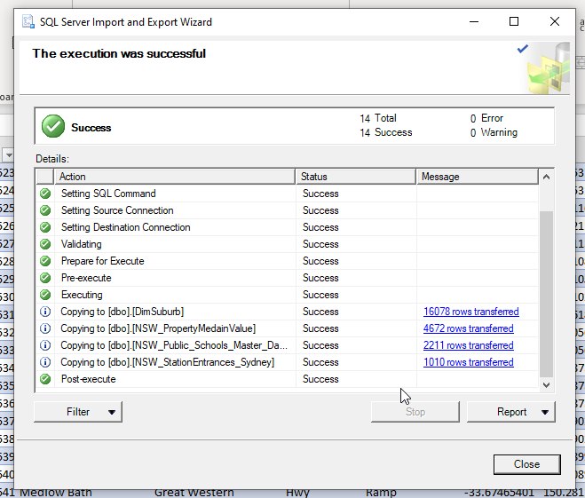

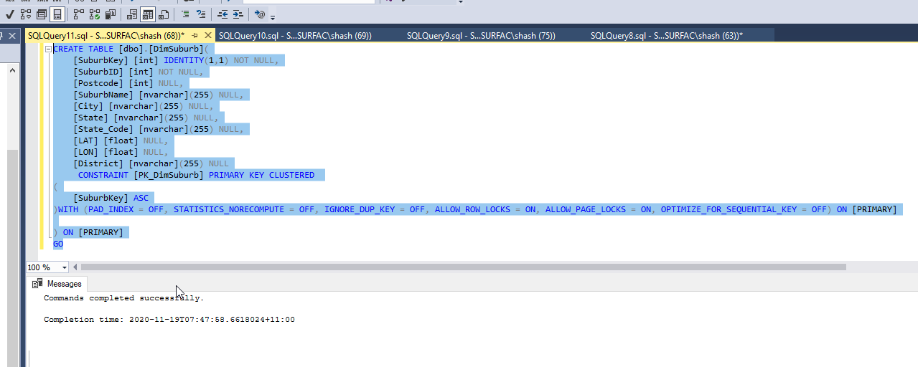

CREATE TABLE [dbo].[DimSuburb](

[SuburbKey] [int] IDENTITY(1,1) NOT NULL,

[SuburbID] [int] NOT NULL,

[Postcode] [int] NULL,

[SuburbName] [nvarchar](255) NULL,

[City] [nvarchar](255) NULL,

[State] [nvarchar](255) NULL,

[State_Code] [nvarchar](255) NULL,

[LAT] [float] NULL,

[LON] [float] NULL,

[District] [nvarchar](255) NULL

CONSTRAINT [PK_DimSuburb] PRIMARY KEY CLUSTERED

(

[SuburbKey] ASC

)WITH (PAD_INDEX = OFF, STATISTICS_NORECOMPUTE = OFF, IGNORE_DUP_KEY = OFF, ALLOW_ROW_LOCKS = ON, ALLOW_PAGE_LOCKS = ON, OPTIMIZE_FOR_SEQUENTIAL_KEY = OFF) ON [PRIMARY]

) ON [PRIMARY]

GO

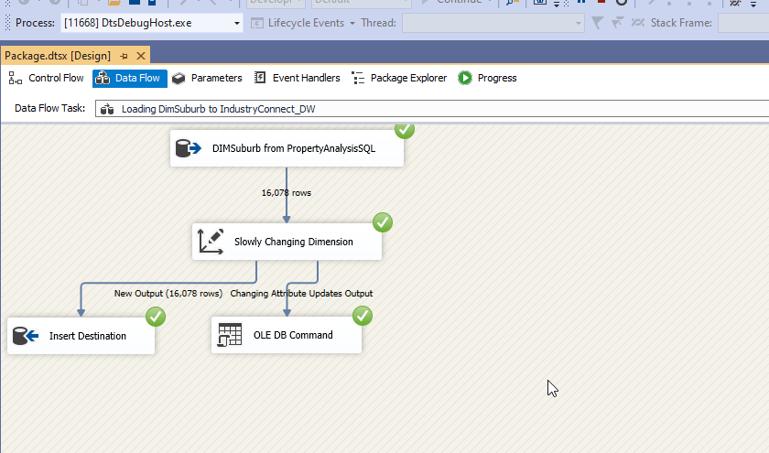

Creation of Table – FactPropertyMedainValue_NSW

USE [PropertyAnalysisDW]

GO

/****** Object: Table [dbo].[DimSuburb] Script Date: 24/11/2020 7:33:09 AM ******/

SET ANSI_NULLS ON

GO

SET QUOTED_IDENTIFIER ON

GO

CREATE TABLE [dbo].[FactPropertyMedainValue_NSW](

[PropertyMedianKey] [int] IDENTITY(1,1) NOT NULL,

[PropertyMedianID] [int] NOT NULL,

[SuburbKey] [int] NOT NULL,

[DateKey] [int] NOT NULL,

[PropertyMedianValue] [float] NULL,

CONSTRAINT [PK_FactPropertyMedainValue_NSW] PRIMARY KEY CLUSTERED

(

[PropertyMedianKey] ASC

)WITH (PAD_INDEX = OFF, STATISTICS_NORECOMPUTE = OFF, IGNORE_DUP_KEY = OFF, ALLOW_ROW_LOCKS = ON, ALLOW_PAGE_LOCKS = ON, OPTIMIZE_FOR_SEQUENTIAL_KEY = OFF) ON [PRIMARY]

) ON [PRIMARY]

GO

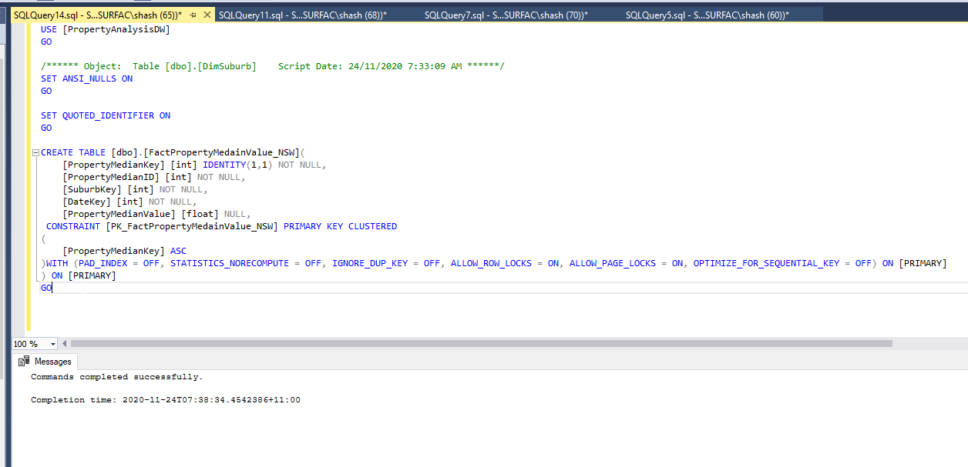

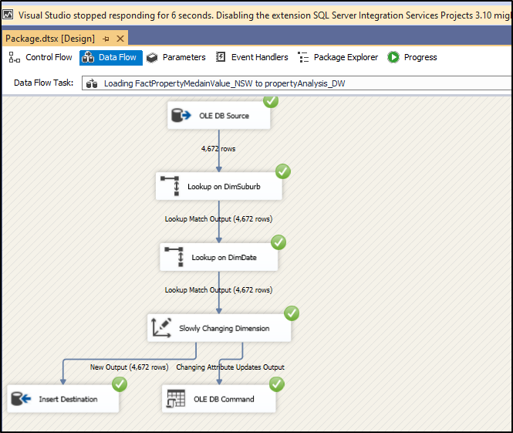

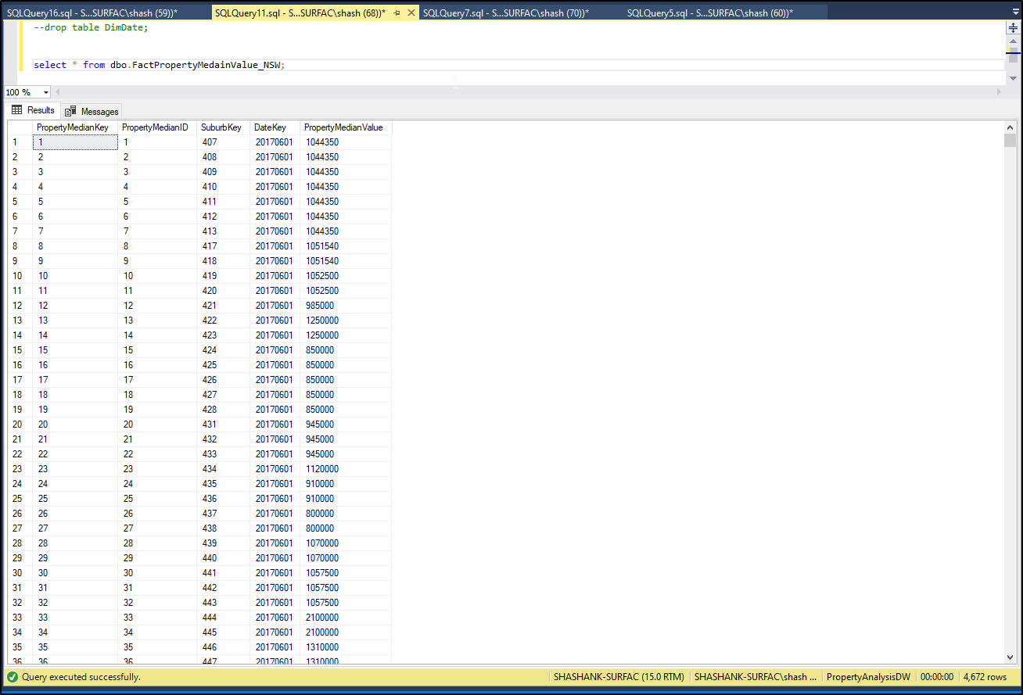

USE [PropertyAnalysisDW]

GO

/****** Object: Table [dbo].[NSW_StationEntrances_Sydney] Script Date: 25/11/2020 7:35:23 AM ******/

SET ANSI_NULLS ON

GO

SET QUOTED_IDENTIFIER ON

GO

CREATE TABLE [dbo].[DimStationEntrancesSydney](

[StopKey] [int] IDENTITY(1,1) NOT NULL,

[StopId] [int] NOT NULL,

[TrainStation] [nvarchar](50) NOT NULL,

[StreetName] [nvarchar](50) NOT NULL,

[StreetType] [nvarchar](50) NULL,

[EntranceType] [nvarchar](50) NOT NULL,

[LAT] [float] NOT NULL,

[LONG] [float] NOT NULL,

[Exit_Number] [int] NULL,

[Mode] [nvarchar](50) NOT NULL,

[StateCode] [nvarchar](50) NOT NULL,

CONSTRAINT [PK_StationEntrancesSydney] PRIMARY KEY CLUSTERED

(

[StopKey] ASC

)WITH (PAD_INDEX = OFF, STATISTICS_NORECOMPUTE = OFF, IGNORE_DUP_KEY = OFF, ALLOW_ROW_LOCKS = ON, ALLOW_PAGE_LOCKS = ON, OPTIMIZE_FOR_SEQUENTIAL_KEY = OFF) ON [PRIMARY]

) ON [PRIMARY]

GO

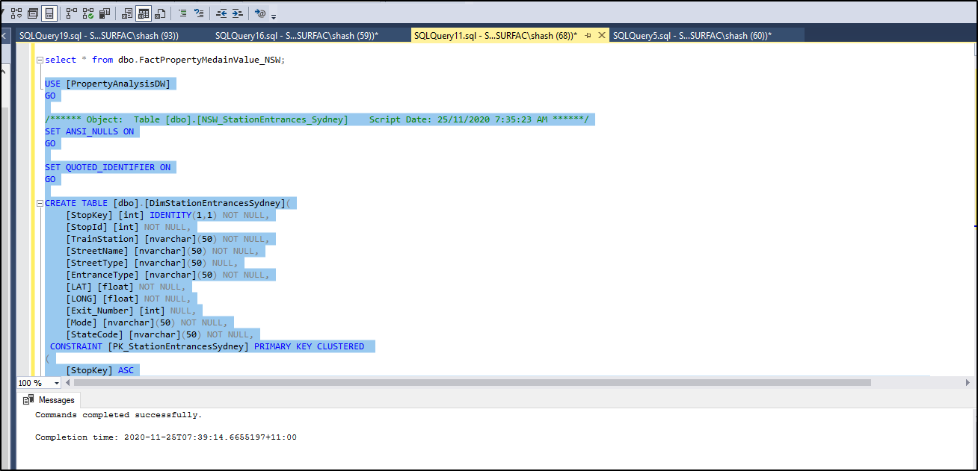

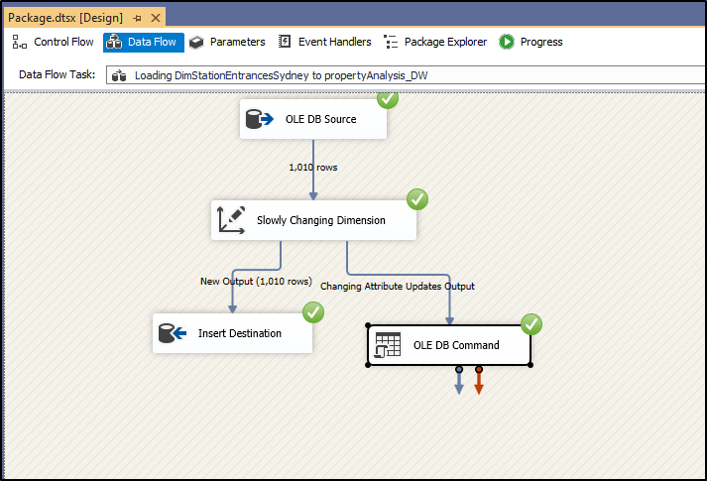

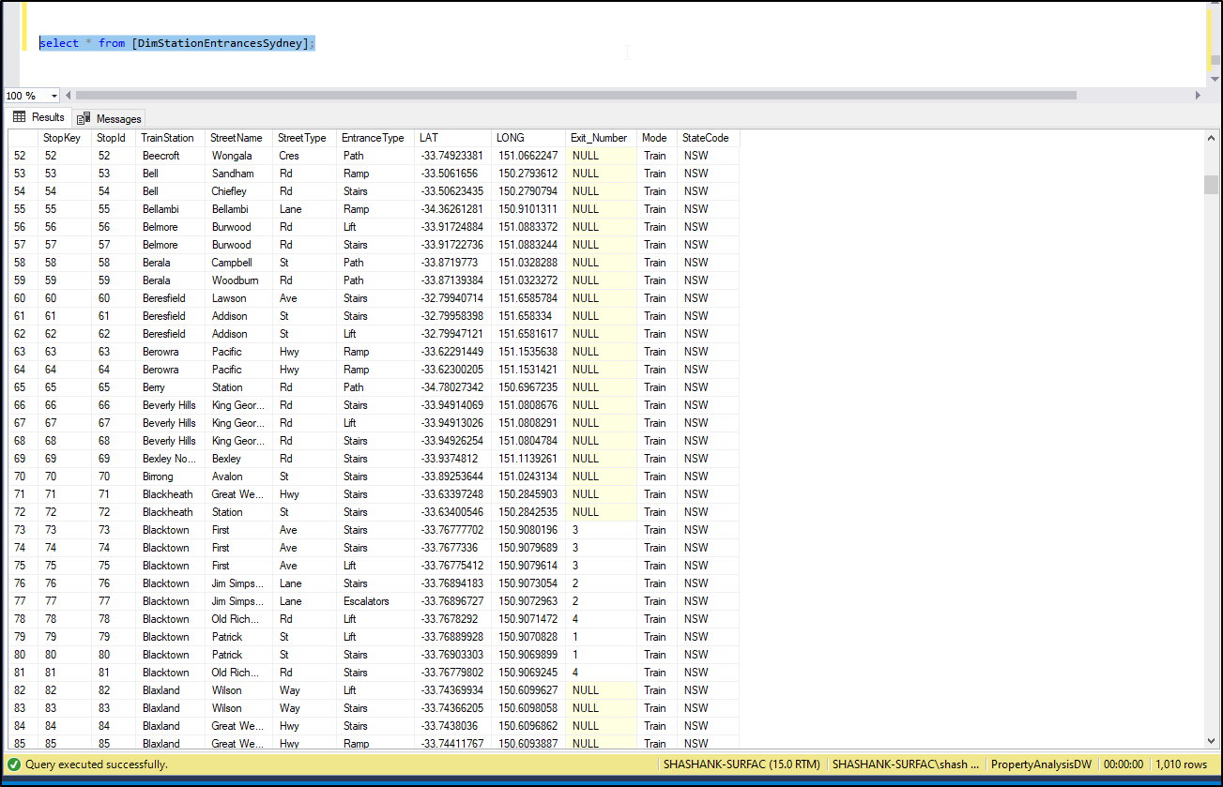

USE [PropertyAnalysisDW]

GO

/****** Object: Table [dbo].[NSW_Public_Schools_Master_Datas] Script Date: 25/11/2020 7:53:27 AM ******/

SET ANSI_NULLS ON

GO

SET QUOTED_IDENTIFIER ON

GO

CREATE TABLE [dbo].[FactPublicSchoolsDatasNSW](

[SchoolKey] [int] IDENTITY(1,1) NOT NULL,

[School_ID] [int] NOT NULL,

[AgeID] [int] NULL,

[School_Name] [nvarchar](255) NULL,

[Street] [nvarchar](255) NULL,

[Town_Suburb] [nvarchar](255) NULL,

[Postcode] [int] NULL,

[SuburbKey] [int] NULL,

[Student_Number] [int] NULL,

[Indigenous_Pct] [float] NULL,

[Lbote_Pct] [float] NULL,

[Icsea_Value] [float] NULL,

[Level_Of_Schooling] [nvarchar](255) NULL,

[Selective_School] [nvarchar](255) NULL,

[Opportunity_Class] [nvarchar](255) NULL,

[School_Specialty_Type] [nvarchar](255) NULL,

[School_Subtype] [nvarchar](255) NULL,

[Support_Classes] [nvarchar](255) NULL,

[Preschool_Ind] [nvarchar](255) NULL,

[Distance_Education] [nvarchar](255) NULL,

[Intensive_English_Centre] [nvarchar](255) NULL,

[School_Gender] [nvarchar](255) NULL,

[Phone] [nvarchar](255) NULL,

[School_Email] [nvarchar](255) NULL,

[Fax] [nvarchar](255) NULL,

[Late_Opening_School] [nvarchar](255) NULL,

[Date_1St_Teacher] [nvarchar](255) NULL,

[Lga] [nvarchar](255) NULL,

[Electorate] [nvarchar](255) NULL,

[Fed_Electorate] [nvarchar](255) NULL,

[Operational_Directorate] [nvarchar](255) NULL,

[Principal_Network] [nvarchar](255) NULL,

[Facs_District] [nvarchar](255) NULL,

[Local_Health_District] [nvarchar](255) NULL,

[Aecg_Region] [nvarchar](255) NULL,

[Asgs_Remoteness] [nvarchar](255) NULL,

[Latitude] [float] NULL,

[Longitude] [float] NULL,

[DateExtractedKey] [int] NULL,

CONSTRAINT [PK_FactPublicSchoolsDatasNSW] PRIMARY KEY CLUSTERED

(

[SchoolKey] ASC

)WITH (PAD_INDEX = OFF, STATISTICS_NORECOMPUTE = OFF, IGNORE_DUP_KEY = OFF, ALLOW_ROW_LOCKS = ON, ALLOW_PAGE_LOCKS = ON, OPTIMIZE_FOR_SEQUENTIAL_KEY = OFF) ON [PRIMARY]

) ON [PRIMARY]

GO

